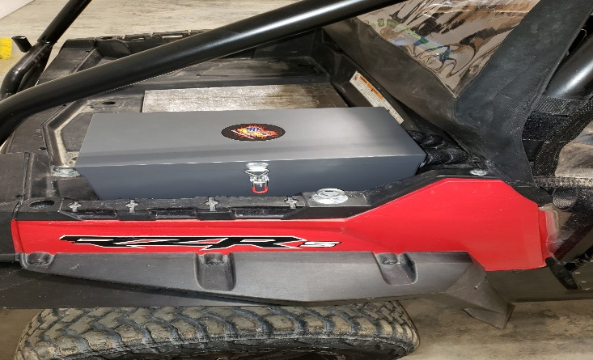
1 – Determine your mounting location (Fig 1)
Fig 1
2 – Locate bypass line on motor (Fig 2)
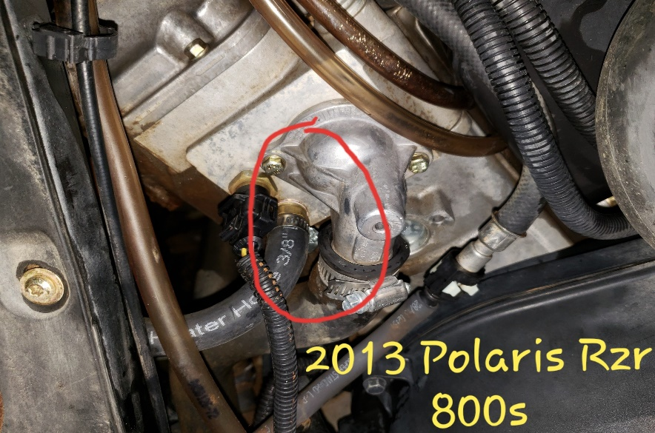
**If unsure, contact dealer to inquire about your model’s make and location of bypass line**
Fig 2
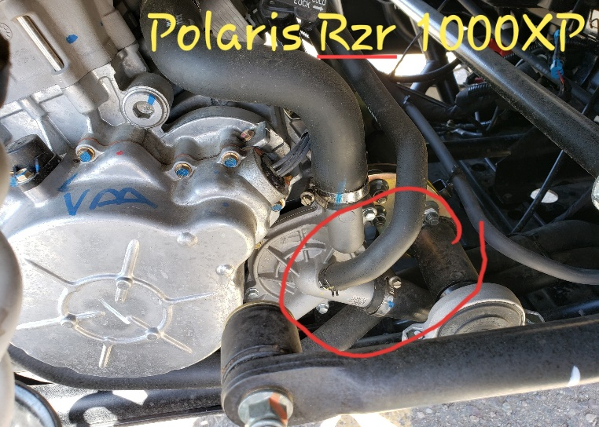
3 – Determine where to route hose to box, drill for hose ¾” - 1” hole
4 – Take two (2) needle nose vise grips, pinch off and cut bypass hose in half, approximately centered or best spot to go up through the bed to the predetermined mount location
Fig 2
**Some models will require a bit more intricate work – see website video for general instruction assistance**
5 – Insert the two (2) 3/8” couplers, supplied in Install Kit, and clamp on bypass line with stainless steel hose clamps. Use the oetiker clamps and attach to supplied hose to couplers (Fig 3)
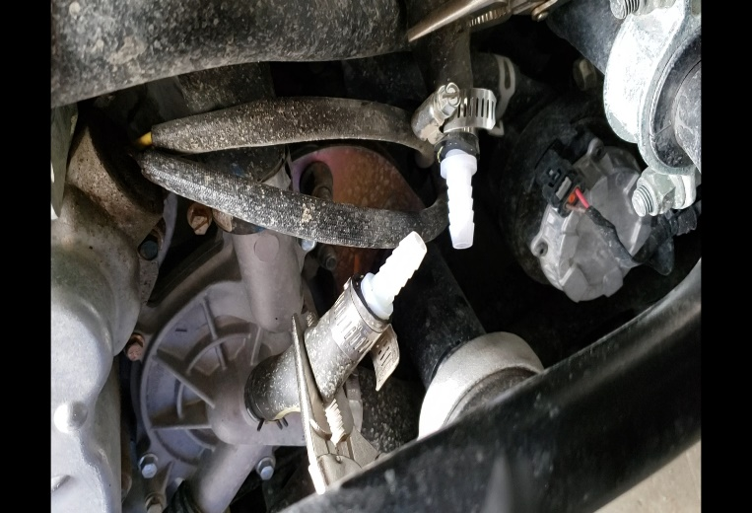
6 – Take clamped 3/8” hoses and run up through the holes drilled in bed to box mounting location
7 – Cut hose to desired length and fill with antifreeze compatible to your unit
8 – Unclamp vise grips – you now should have full lines to motor with no air
9 – Take supplied 4” length of clear hose, put on left side outlet of the A.T. Hotbox as you face it. With small funnel fill the A.T. Hotbox line with antifreeze (this should take approximately 14 ounces)
Fig 3
10 – Connect hose to the A.T. Hotbox with other two oetiker clamps. Check hoses to make sure not hitting exhaust or rubbing on anything. Zip tie as needed to prevent any potential rubbing
11 – Start unit and inspect for leaks. Allow to idle as to get to running temperature (usually approximately 180*), blip throttle a few times to assist any air bubbles that may have gotten caught in line while filling
**12 – Some ATVs/4 wheelers may require combo tee in radiator lines as many do not have a bypass warm up line. You will need to find out line size from dealer for your specific model to get correct size combo tee. Combo tee sizes required for most ATVs are available on our website.

